**/Users/ngoh/Desktop/schema3.pdf**

Explanation for diagram:

Books Entity: 11 attributes are required to capture information about the books available in the online store. ISBN-13 is chosen as primary key.

Customers: 7 attributes are required to capture information about the books available in the online store. “login_name” is chosen as primary key.

Shopping Cart Entity: Making customers’ orders an entity enables each user to order multiple number of books with multiple copies each. This is a temporary table to be dropped every time a user checks out or logs off.

Orders Relationship : 6 attributes are required. The primary key is (login_name, ISBN-13, order_date, order_time) . Each person ordering a book at a particular date and time should be unique. This table is also where users can retrieve information about their order history.

Orders Relationship : 6 attributes are required. The primary key is (login_name, ISBN-13, order_date, order_time) . Each person ordering a book at a particular date and time should be unique. This table is also where users can retrieve information about their order history.

Function 1: Registration

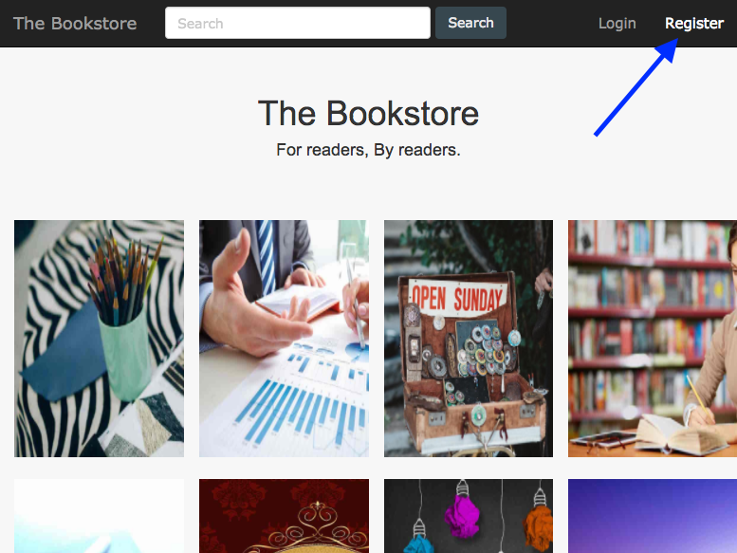On reaching our homepage, users are able to register by clicking the register button on the top right corner of the page.

On clicking they will be brought to a page to input their necessary information: login name (email), password, first and last name, credit card number, address and phone number.

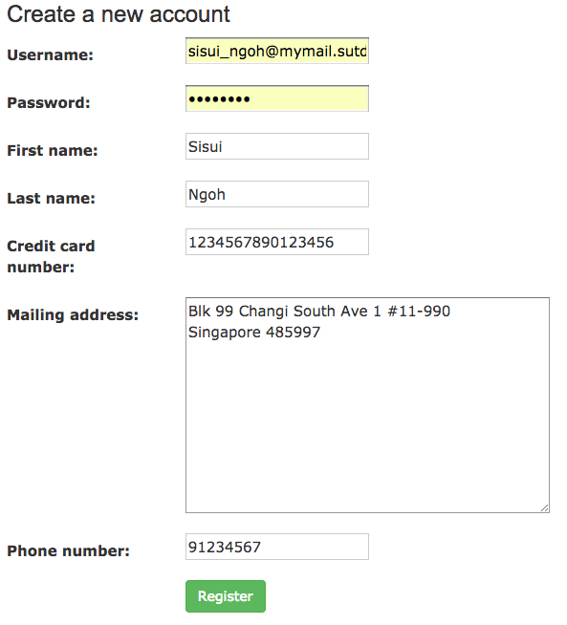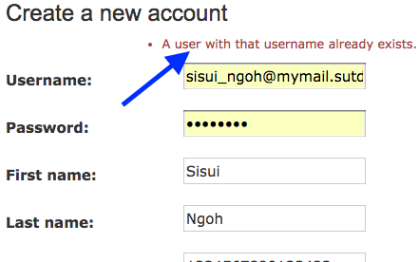The login name is checked for uniqueness via an error message if it already exists.

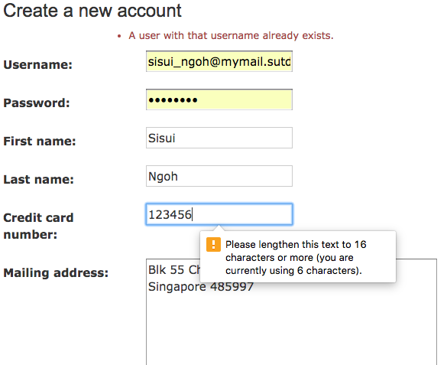The 16 digit credit card checking is also done via an error message.

Function 2: Ordering

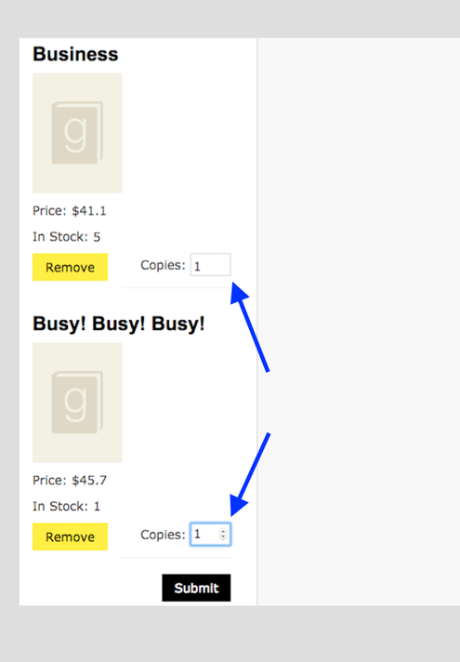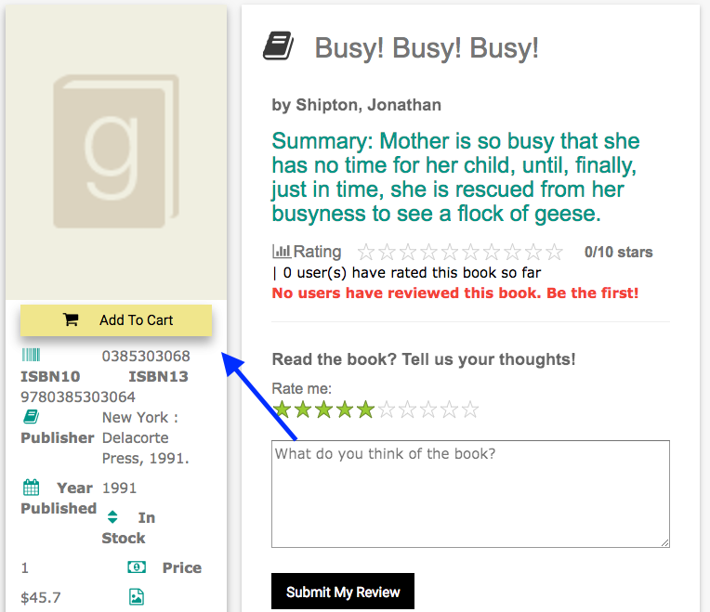A shopping cart is implemented so that a user may order multiple books with multiple copies each. On seeing a book of interest, users may select “Add To Cart” and submit their order if they are satisfied with their choice of books and their quantity.

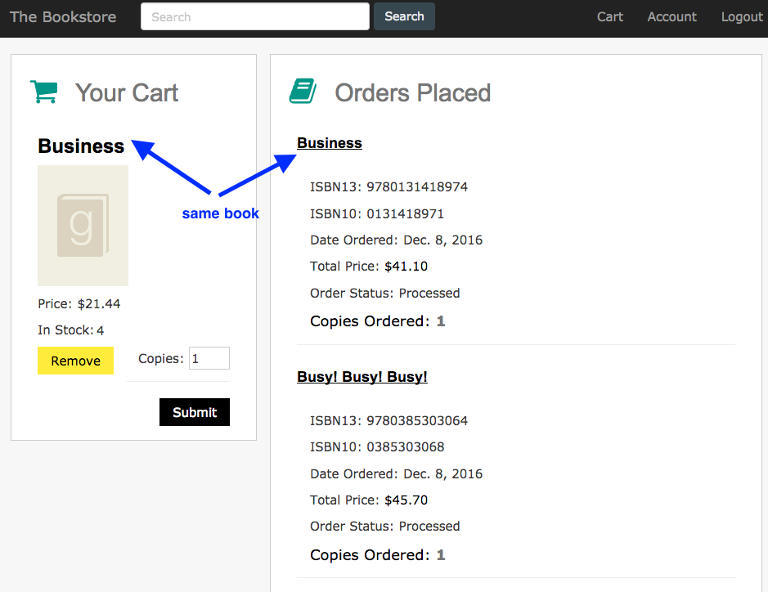Users who have placed their orders may go back and add the same book to their now empty cart.

Function 3: User Record

On clicking “account” on the top right corner of the page, users are able to view their account information, full history of orders and full history of feedbacks.

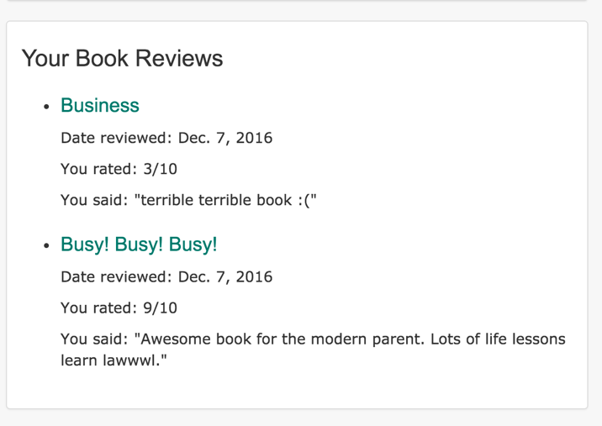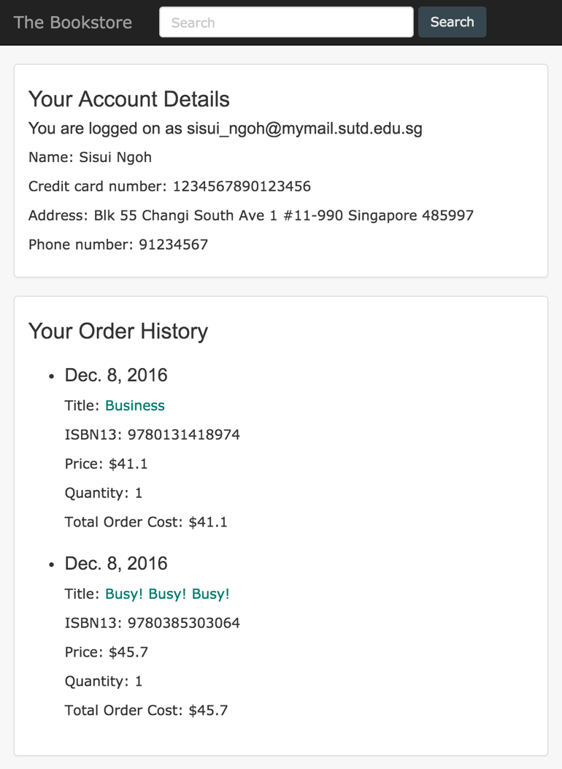

Function 4: New Book

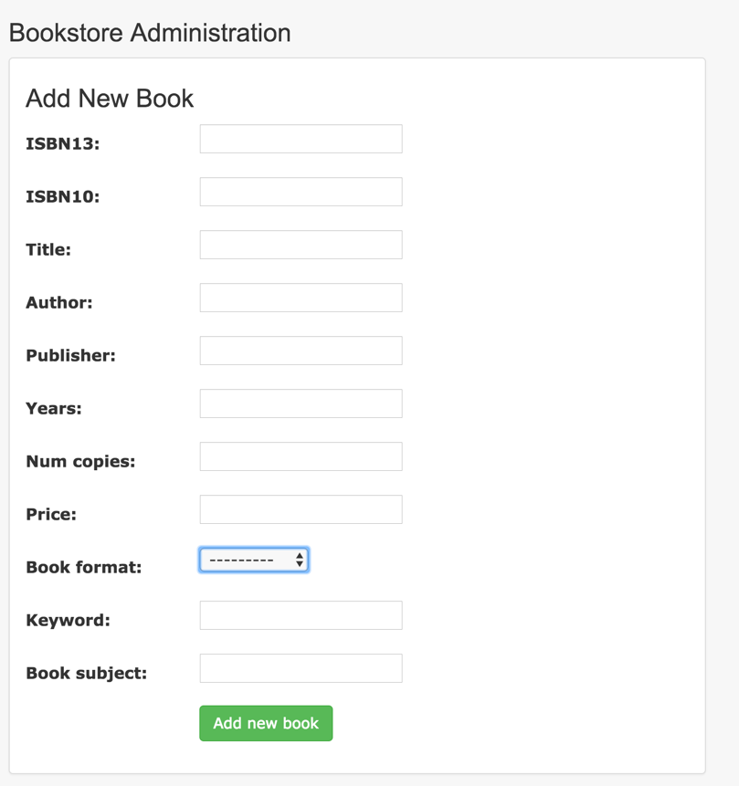The admin is able to log in with an admin login name and password. On doing so, the top right of the page has an “Admin” page that allows the admin to add a new book along with all the necessary details shown below.

Function 5: Arrival of more copies

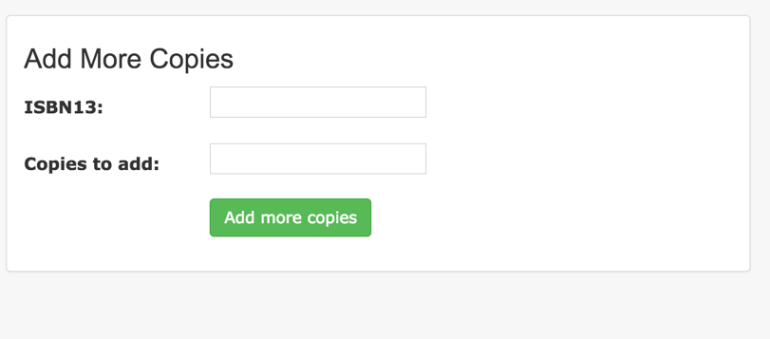Within the admin page, the admin is also able to update stock of new copies by simply typing its ISBN-13 and the number of copies to add.

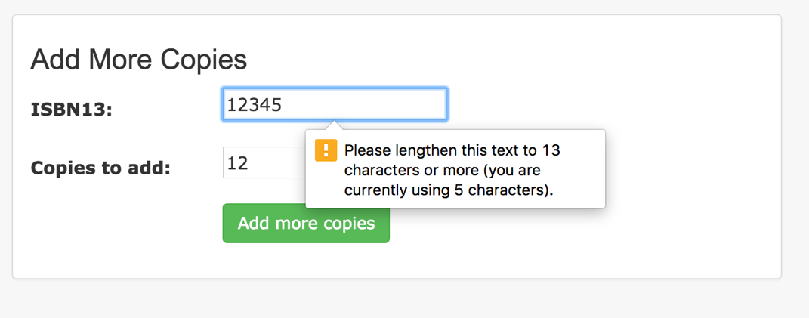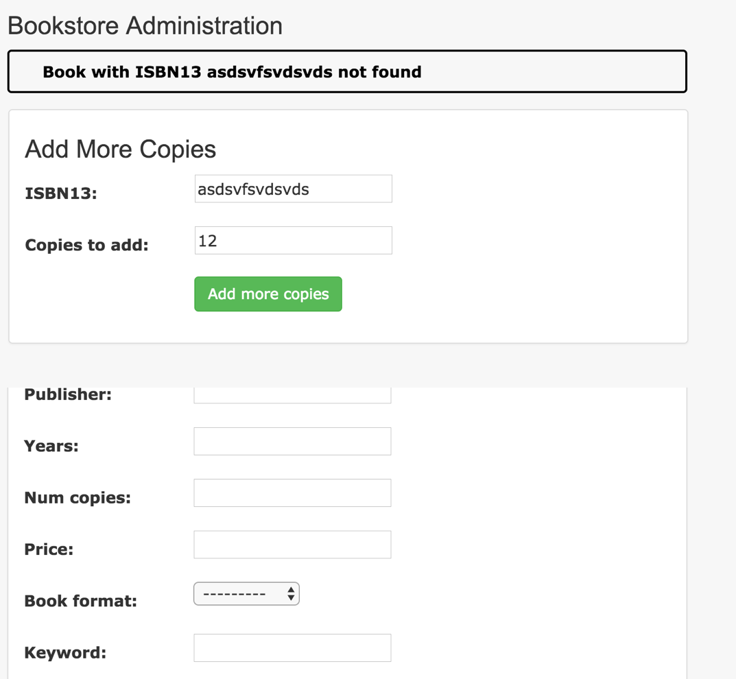If the admin adds an invalid ISBN-13 (an ISBN-13 that does not already exist in the database), an error message appears that prevents the updating of that book.

Function 6: Feedback recordings

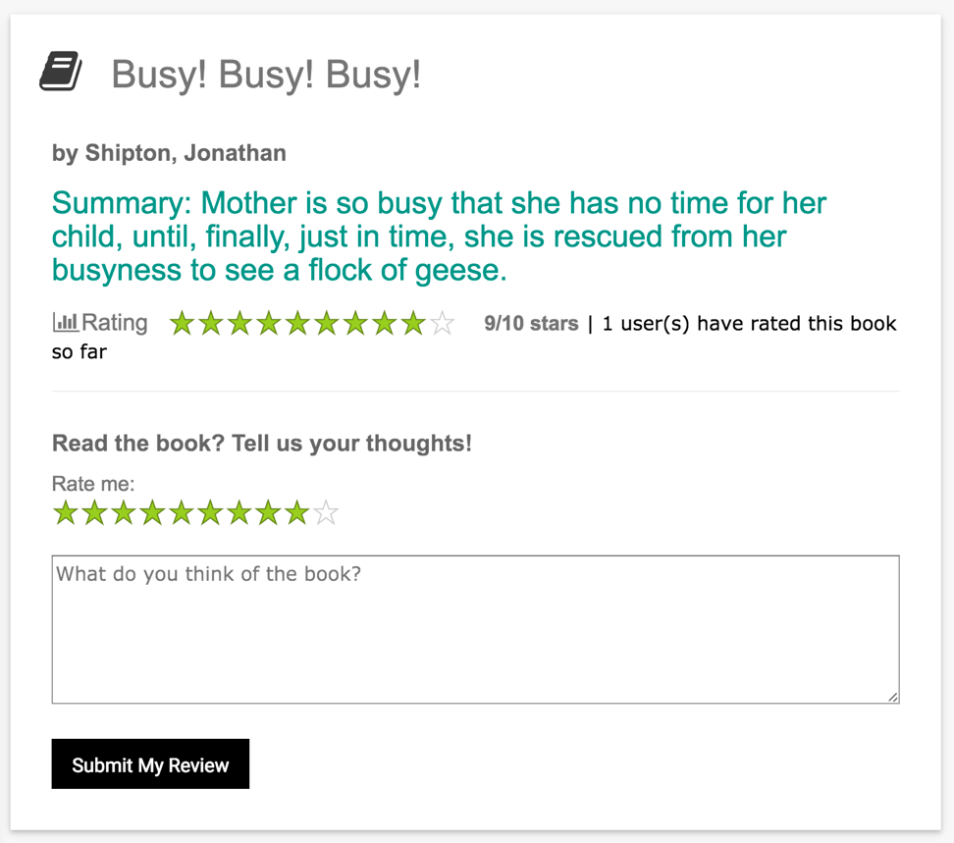In each book’s page, users are able to recordtheir feedback for that book. They do so in the form of a numerical score (out of 10) and also an optional text. Theses details as well as the date of the feedback is recorded.

Function 7: Usefulness ratings

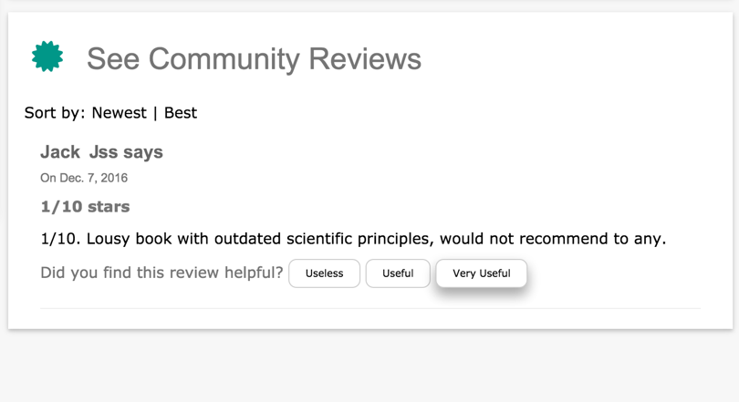If there are any other reviews for a book that user is viewing, he is able to assess those feedbacks.

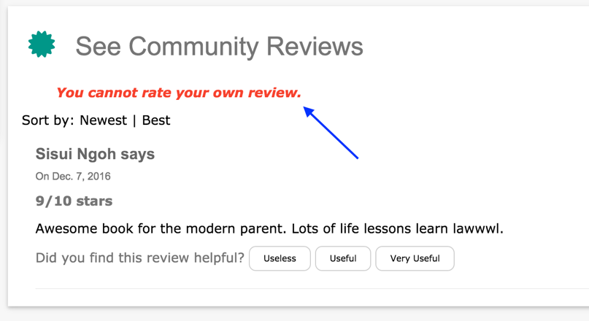The user is able rate their feedbacks. If a user tries to rate his own feedback, the following error message occurs that does not allow him to do so.

Function 8: Book Browsing

In all pages, there is a search bar that allows for conjunctive queries on authors, and/or publishers, and/or titles, and/or subject. The following screenshot shows a search for a book’s title “Busy! Busy! Busy!”and the author “Jonathan Shipton”. Users are also able to sort them either by user rating (average score of feedbacks) or year.

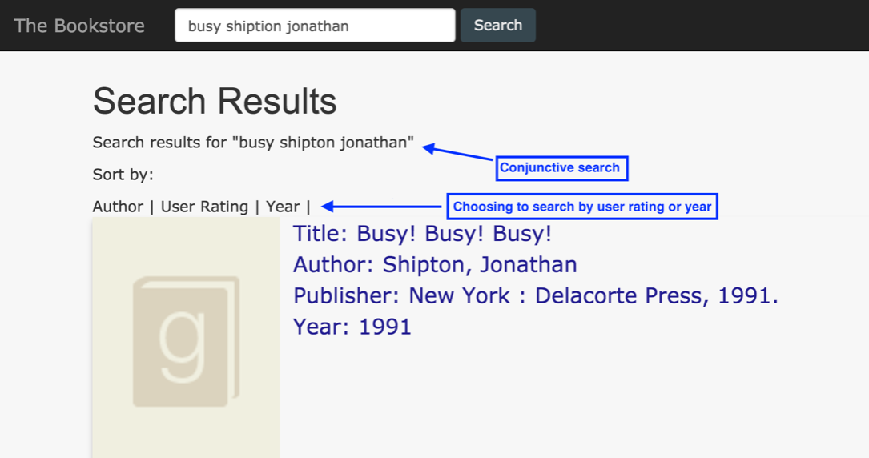

Function 9: Useful feedbacks

For a given book, a user is able scroll down its page to see the most useful feedback in decreasing order. The usefulness is defined by the average of the ratings given to that feedback.

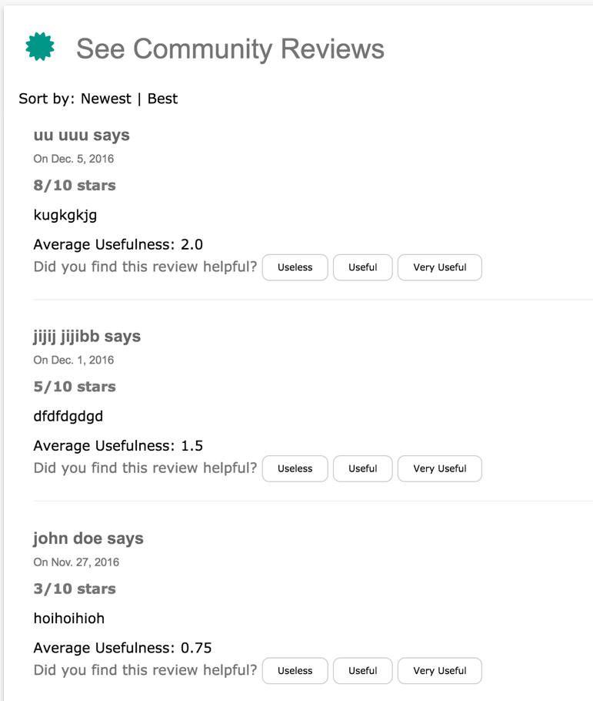

Function 10: Book Recommendation

At the bottom of the home page, users are able to see a list of other suggested books. These books are sorted in decreasing sales count. These books are suggested if they are bought by another user who also bought the same books as the current user.

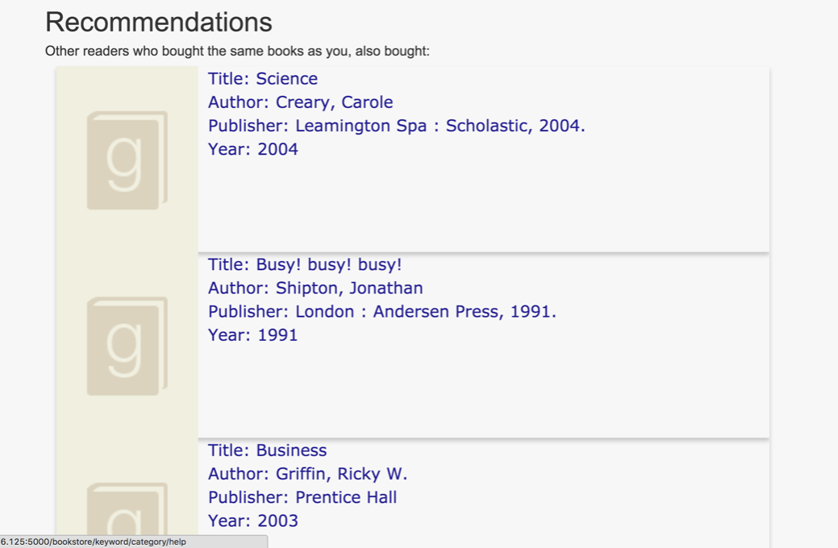

Function 11: Statistics

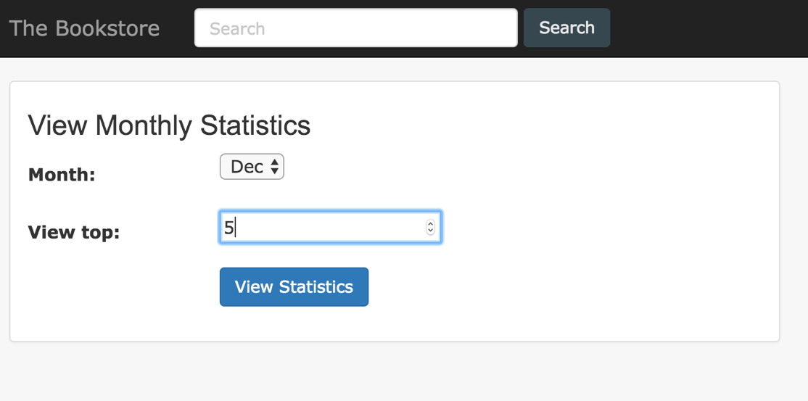The admin may also log in and check click the “stats” tab to obtain statistics about a particular month. Once in the page, he can select the month and the top *m* highest stats.

The page will then load the top m most popular books, authors and publishers

